**Movie API**

**Project Structure**

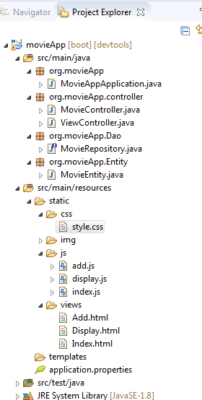

**Java Files:**

1. **MovieAppApplication –** Main method
2. **MovieController –** RestController
3. **ViewController –** Front end View Controller
4. **MovieRepository –** Works as Dao object
5. **MovieEntity –** Entity class for movie table

**Views:**

1. **Index.html –** Home page

<http://localhost:8080/index>

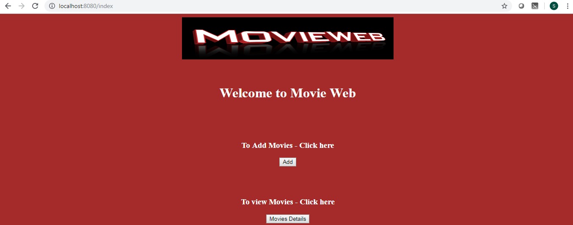

1. **Add.html -** To add movies

<http://localhost:8080/add>

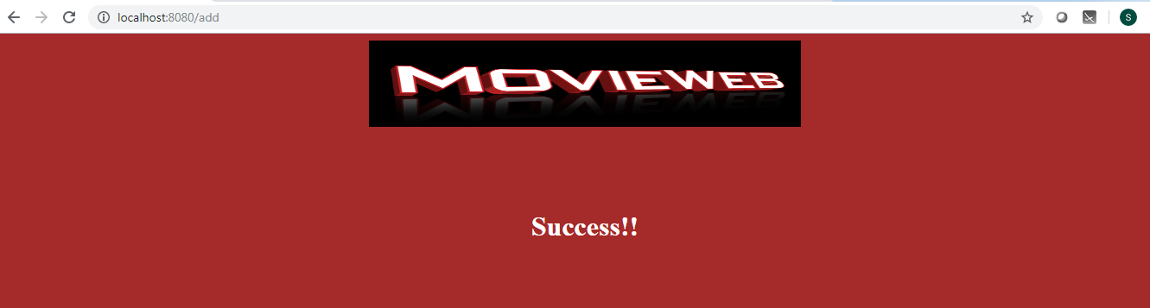

Error message

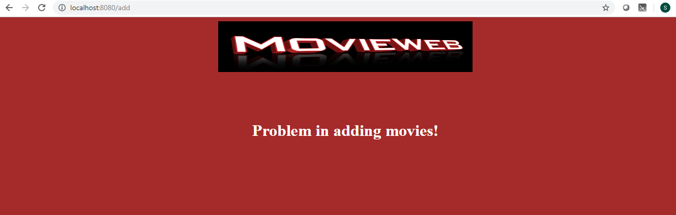

1. **Display.html –** Display movie details

<http://localhost:8080/display>

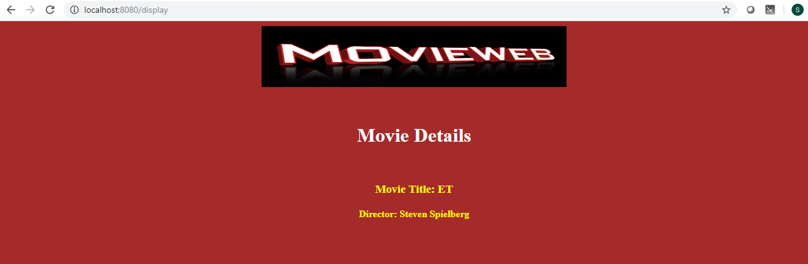

Movie details are not available

